Drawing II: Clayboard Illustration
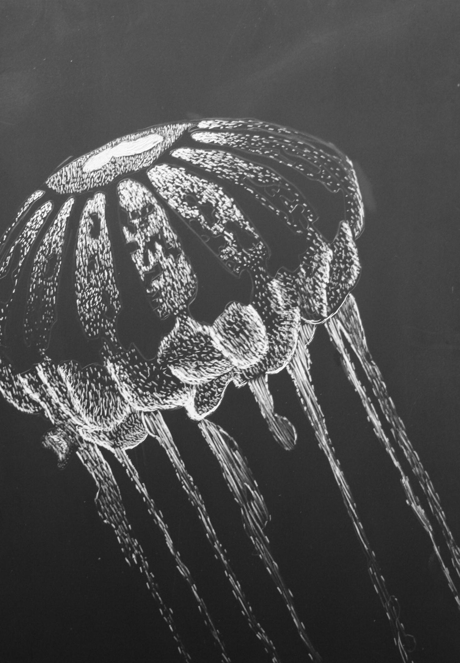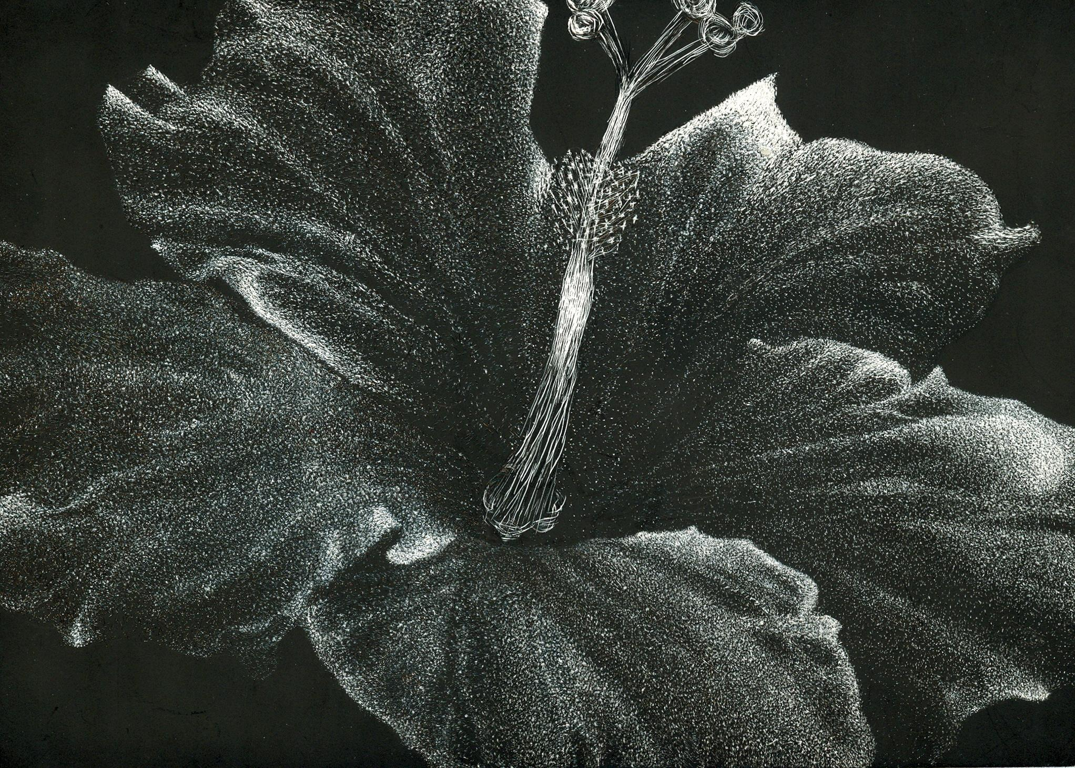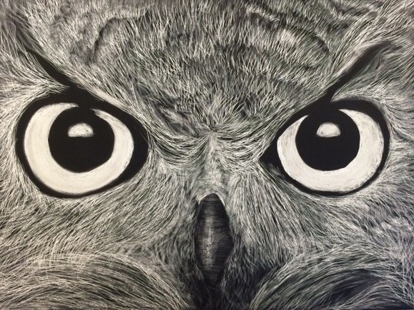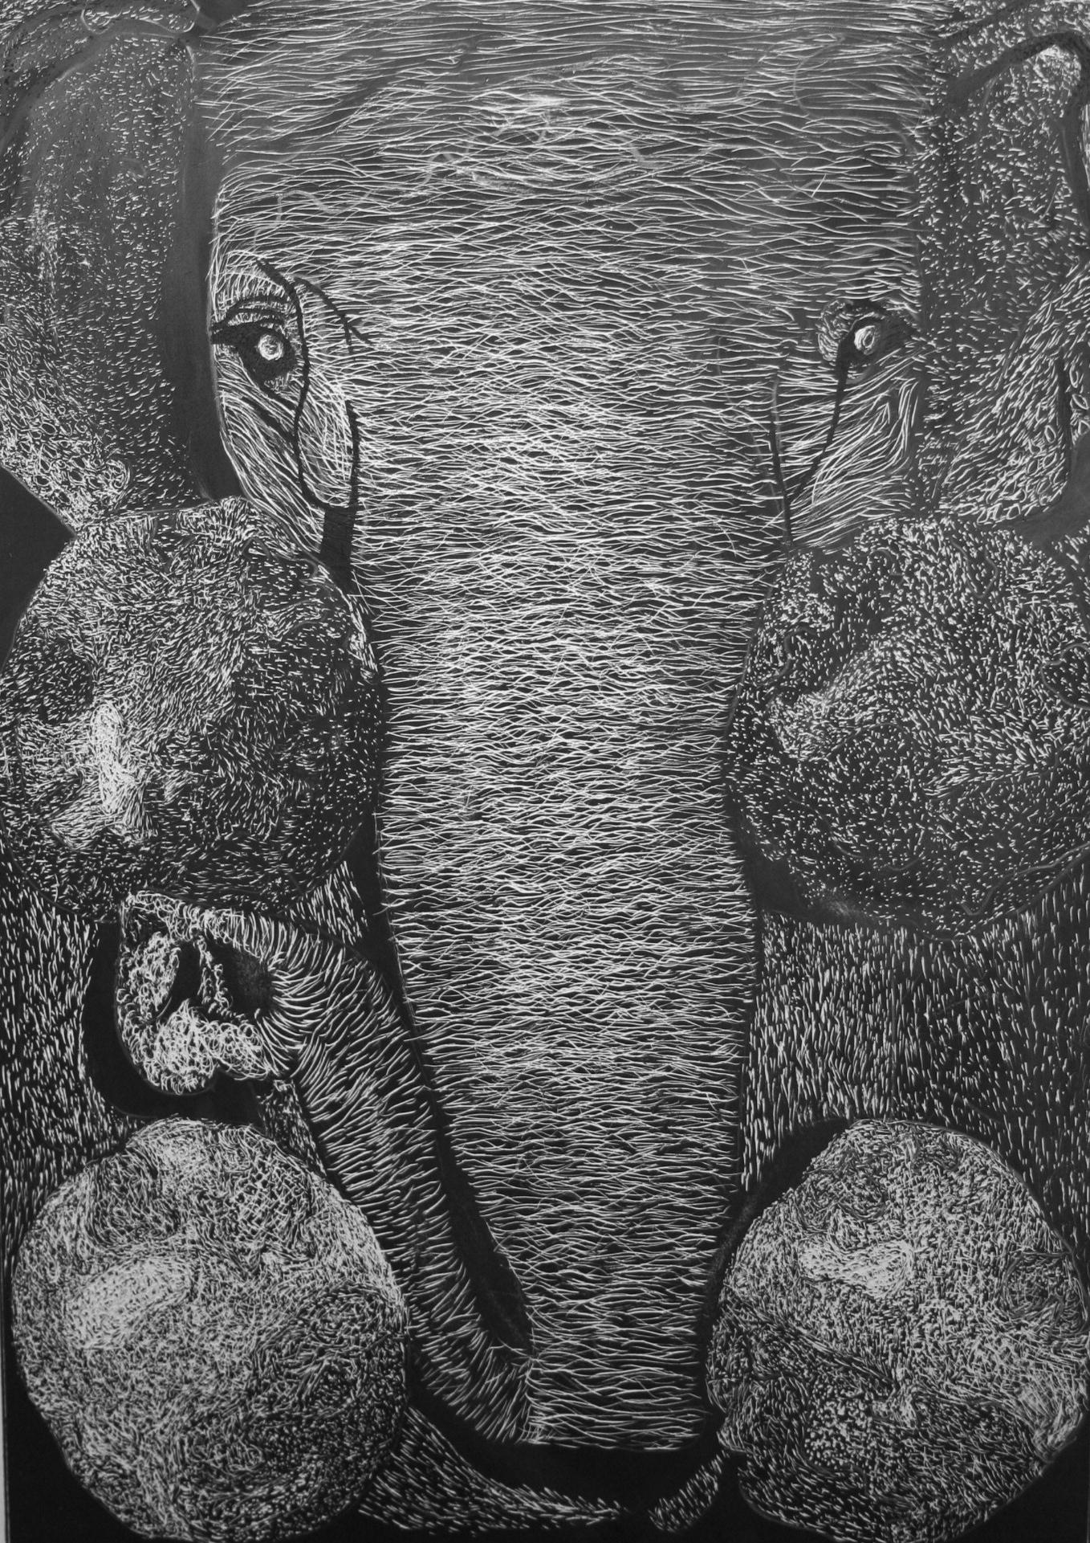
Overview:
You will use what you have learned about value and texture to create a black and white clayboard illustration. Using different types of strokes with your engraving tool, you will create different textures and values. You will create an illustration that shows your understanding of how to visually represent these items. Feel free to incorporate any additional textures (in the background or empty spaces) you find necessary to help your illustration reach its maximum potential!
Objectives:
- Learn how to use scratch art tools to create an illustration on clayboard.
- Demonstrate your understanding of texture and value within your illustration.
Requirements:
- Complete the 8 texture practice squares on scratchboard
- Include value and texture

Clayboard Illustration - Grading Rubric

Requirements: Student used class time to complete the texture squares and the clayboard illustration. Student shows understanding of how to use scratch art tools with scratchboard and clayboard medium. Student included value and texture within their piece.

Did not meet requirements Met one or two Met all expectations
requirement(s) but not the other(s)
1 2 3 4 5

Composition and Layout: Illustration should have an interesting composition. Student shows understanding of the elements of design (line, shape, value, color, size, texture, space). Student paid attention to detail and created a piece that reads as a comprehensive whole.
Design uninteresting/ Somewhat interesting/ Awesome/
poor placement good placement great placement
1 2 3 4 5

Techniques and Craftsmanship: Student worked carefully and neatly to create a finished work of art that shows a high level of craftsmanship. Special attention should be given to value and texture. Final design should be done to the highest quality and show a great deal of care.
Poor craftsmanship Average Great craftsmanship
1 2 3 4 5

Effort: Student worked diligently, asked questions when unsure, used tools properly and safely, and turned completed project in on time.

Misused most time Some time wasted Used all time wisely
1 2 3 4 5

I feel that I earned a/an _____ for my Clayboard Illustration because…
(letter grade)

Teacher Evaluation Grade: _____________

