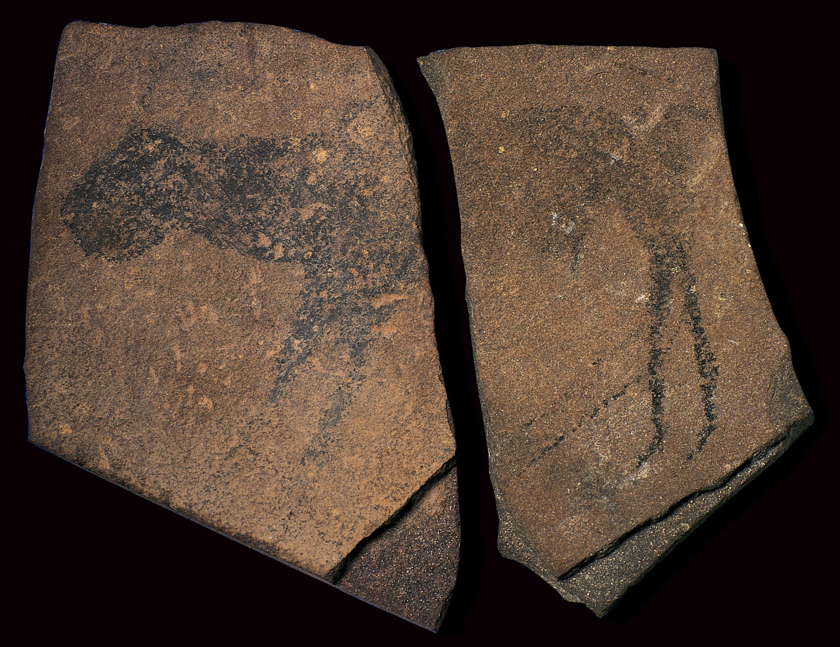
Each snapshot will include the official image(s) for the piece provided by the College Board
Image #/Title
Unit 1 | - Global Prehistory - 30,000 - 500 BCE  There are 10 units, this area will already be filled so you know what unit the piece is in
Links  To articles and videos | This is where I will provide the links to the articles/videos in order to fill out the snapshot
IDENTIFIERS  Title/designation  Artist/Culture  Date of creation  Materials | Identifiers include:  - the title of the work  - the name of the artist or culture that produced the work  - the date of creation  - the materials used in the work.  **Dates should always have either bce or ce after the number do not use bc or ad  **There are times when we do not know the specific artist, but we might know who it was made for. Especially in the earliest art we study.  **For the exam, at least two of these identifiers must be present and correct for full credit; however, students will not be penalized if additional identifiers are incorrect.
FORM  Use of design elements/principles: color, shape, value, texture, line, space; balance, contrast, emphasis, movement, etc | Finer details. What does it look like? Look at color, shapes, texture, medium, etc.
MATERIALS & TECHNIQUES  Art making processes and use of material | What materials is this piece made out of? Get as specific as you can.“Paint” is not specific enough but oil paint or tempera paint are. “Rock” is too general but limestone or concrete are more specific.
CONTENT  Subject matter, iconography, depiction, symbolism, the story | Who/What is the subject? What do they represent? Is there a narrative/story?  (Think: Political, Economics, Religious, Social, Intellectual, Art)
CONTEXT  place/site/audience: why was the artists’s intent significant? | Why? What’s the story? What was happening during this time that caused this piece to be created? (Think: Political, Economics, Religious, Social, Intellectual, Art) What does this work tell us about the time, place, and culture that produced it?  Were there any outside/external influences that impacted the work? Is there a backstory that helps explain what’s going on?
INTENDED FUNCTION & PURPOSE  Why was it made?  PATRON  Who was it made for? | What is its purpose? What was the work made for? Was it religious, utilitarian, political, or just for making art?  The Patron is who the art was made for, or commissioned by. We don’t always know this, but if you do it’s a good fact to include.
INNOVATION/CHANGE | Does this piece show any innovation in technique or the technology happening at the time or does it show any changes happening during that era/time period?
CONVENTION/  TRADITION | Does this piece reflect the traditions of the time period or area in which it was created? How so?
THEME(S) | Is there a theme to the piece that the artist is trying to get across?
COMPARE TO ANOTHER WORK(S) | How can you compare this to other works we have seen?  This will be hard to fill out in the beginning and I will show you comparisons based on different things like techniques, themes, subject matter, etc.
ADDITIONAL NOTES/DRAWINGS

