1. Line is an ______________________ of art.

2. Rhythm and Movement are ______________________________ of art.

2. An exhibition of German expressionist art would include works by the painter
1 Munch
2 Krasner
3 Kandinsky
4 Pollock

3. Artist Edvard Munch is considered to be a _______________________ to Expressionism.

4. The best way to describe the work of Edvard Munch would be
1 that he used mostly nonobjective lines achieved through action painting
2 that he used mostly geometric shapes and lines to express himself
3 that he was famous for expressing himself through real-life inspiration
4 that he used repeating shapes in his artwork and all-over painting

5.
Image 1 Image 2 Image 3 Image 4
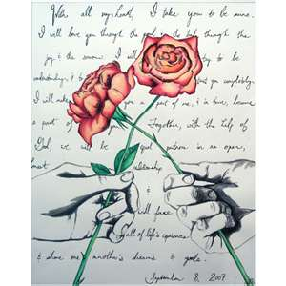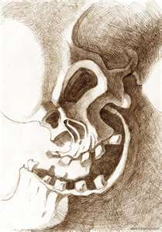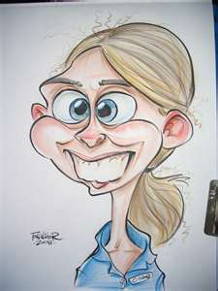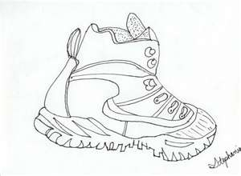
Which of the images shown above would be considered a contour drawing?
1 Image 1
2 Image 2
3 Image 3
4 Image 4 .

6. Choose from the following list of artists and circle the one you plan to write your short response about (examples of these artists’work is on your table):
1 Edvard Munch
2 Jackson Pollock
3 Lee Krasner
4 Wassily Kandinsky
Each one of the artists above has contributed in some way to the artistic style of Expressionism. Use the artist you have chosen to answer this question:
“What are the characteristics of Expressionism and how did the artist you chose fit into this artistic style?”
_______________________________________________________________________________________________________________________________________________________________________________________________________________________________________________________________________________________________________________________.

7. Create sketch using a contour line drawing of an object on your table that creates dynamic tension:

8. What is most successful about the drawing you created? Why?
_______________________________________________________________________________________________________________________________________________________________________________________________________________________________________________________________

9. If you had additional time, what changes you make in this contour drawing above?
_____________________________________________________________________________________

_____________________________________________________________________________________

_____________________________________________________________________________________

10.
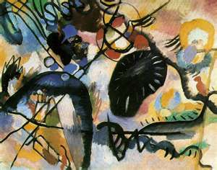

Artist (circle the artist of this work of art): Munch Pollock Krasner Kandinsky
Title: Black Spot
Year (Circle the time period this most likely fits into): 1890-1900 2000-2011 1780-1800
Medium: Oil, tempura and pastel on cardboard
Style: Abstract Expressionism Expressionism German Expressionism

Describe the lines used in this work of art:
_____________________________________________________________________________________

_____________________________________________________________________________________

_____________________________________________________________________________________

_____________________________________________________________________________________

