Selected Response Items:
The following multiple choice questions will each be worth 2 points totally 14 points for the section. Circle the best answer choice for each question.

1 [M11] Turn this mistake into a success:
Circle which way you used to turn your mistake into a success:
1 Erasing and trying again
2 Turning the mistake into something else
3 Making your mistake the main event

2 [M6, A7.6.2] An exhibition of abstract expressionist art would include works by the painter
1 Pollock
2 Munch
3 Kandinsky
4 Klee

3 [M4d, A5.6.1] The best category for ‘Line’ in art would be
1 Principle
2 Element
3 Expressionism
4 Composition

4 [M4d, A5.6.8] The best category for Rhythm/Movement in art would be
1 Principle
2 Element
3 Expressionism
4 Composition

5 [M6, A7.6.2] Artist Edvard Munch is considered to be
1 an artist that is very realistic
2 an abstract expressionist artist
3 a forerunner to expressionism
4 a German expressionist artist

6 [M6, A7.6.2] The best way to describe the work of Jackson Pollock would be
1 that he used mostly nonobjective lines achieved through action painting
2 that he used mostly geometric shapes and lines to express himself
3 that he was famous for, “The Scream”
4 that he was a German expressionist artist

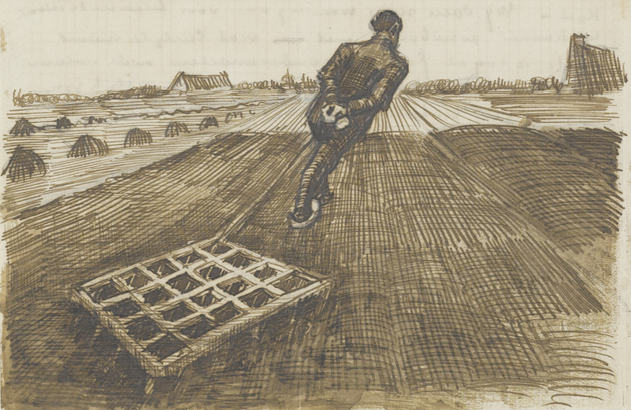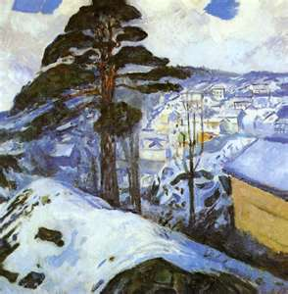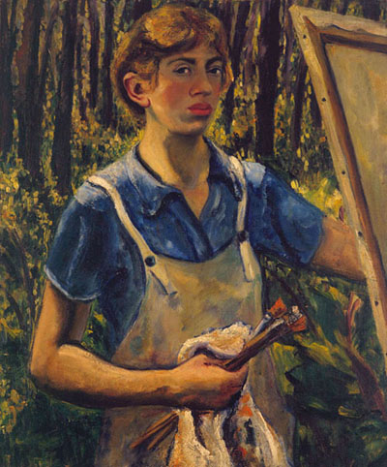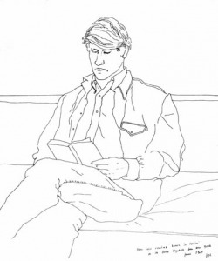
Image 1 Image 2 Image 3 Image 4

7 [M3] Which of the images shown above would be considered a contour drawing?
1 Image 1
2 Image 2
3 Image 3
4 Image 4

Short Constructed Response Items:
This question is worth a total of 10 points (4 points for correctly stating the characteristics of Expressionism, 4 points for correctly stating how the artist they chose fit into this style and 2 points for writing in complete sentences)

8 [M6, A7.6.2] Choose from the following list of artists and circle the one you plan to write your short response about (examples of these artists’work is on your table):
1 Edvard Munch
2 Jackson Pollock
3 Lee Krasner
4 Wassily Kandinsky
Each one of the artists above has contributed in some way to the artistic style of Expressionism. Use the artist you have chosen to answer this question:
“What are the characteristics of Expressionism and how did the artist you chose fit into this artistic style?”
_____________________________________________________________________________________

_____________________________________________________________________________________

_____________________________________________________________________________________

_____________________________________________________________________________________.

Extended Constructed Response Items:
This section is worth a total of 12 points. Question 9 is worth 3 points, 1 point for each correct portion. Question 10 is worth 6 points. Question 11 is worth 2 points and Question 12 is worth 2 points.
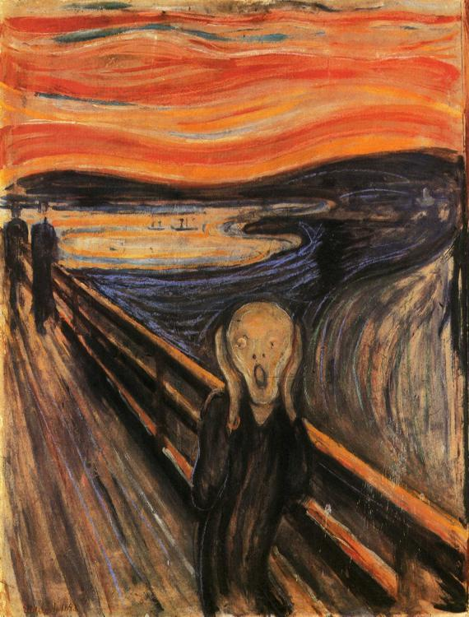
9 Artist (circle the artist of this work of art): Munch Pollock Krasner Kandinsky
Title: The Scream
Year (Circle the time period this most likely fits into): 1890-1900 2000-2011 1780-1800
Medium: Oil, tempura and pastel on cardboard
Style: Abstract Expressionism Forerunner German Expressionism

10 [M2c, A7.6.4] Describe the lines used in this work of art:
____________________________________________________________________________________________________________________________________________________________________________________________________________________________________________________________________________________________________________________________________________________
11 [M4d, A7.6.4] Is this work of art an example of representational, abstract or non-objective art?

_____________________________________________

12[M4d, A7.6.4] How do you know?

__________________________________________________________________________________________________________________________________________________________________________
 | Beginning 1-2 Points | Basic 3-4 Points | Advanced 5-6 Points
Description | -You identified elements of art used.  -May not be able to fully articulate the way the artist used the elements of art  -Lacks some content knowledge about the piece | -You identified and partially described the elements of art, but did not provide sufficient evidence from the work of art.  -there is some evidence of connecting the elements of art created and the techniques used by the artist.  -Expresses content knowledge f the artist/medium | -You accurately identified and described the elements of art used by the artist with many sources of evidence.  -You identified the major characteristics of each element of art (warm/cool colors, qualities of line and shape)
Judgment | -Struggles to evaluate art or can on a very limited level, but struggles to explain the “how you know” portion | -Your judgment discussion includes an appropriate art theory with a short statement listing supporting reasons.  -limited support of theory | -Your judgment discussion includes an appropriate art theory and a complete explanation of your supporting reasons.  -full support of theory (including evidence)

Performance Event Item:
Directions: Now you are going to draw two sketches of the objects given to you on your table that create a sense of dynamic action and tension. This section is worth 8 points. Each sketch is worth 4 points graded on the following rubric:
Level | Description
4 | The sketch is a visually dynamic composition in which all the criteria are met in a highly successful manner.
3 | The final drawing is a visually dynamic composition in which most of the criteria are met in a fairly successful manner.
2 | The final drawing may be visually dynamic but the criteria are met in a limited manner, or the criteria are met fairly well but the drawing is not very dynamic or visually exciting.
1 | The final drawing meets the criteria in a minimal way
0 | Non-scorable-no attempt was made or design is unrelated to task
Consider all the space given in your rectangle. Your composition may be in different poses that could be horizontal or vertical. You may add other shapes or images to the background to enhance the dynamic tension and action of your composition.

13 [M2b, A5.6.1, A5.6.8, A6.6.4, A6.6.5]
Sketch 1:

14 [M2b, A5.6.1, A5.6.8, A6.6.4, A6.6.5]
Sketch 2:

Student Reflection
This section is worth a total 6 points. Questions 15, 16 & 17 are each worth 2 points.

15 [M2c, M3] Describe how you used Line in a visually dynamic way in your final drawing:
_______________________________________________________________________________________________________________________________________________________________________________________________________________________________________________________________

16 [M3] What is most successful about the drawing you created? Why?
_______________________________________________________________________________________________________________________________________________________________________________________________________________________________________________________________
17 [M3] If you had additional time, what changes you make in this composition?
_______________________________________________________________________________________________________________________________________________________________________________________________________________________________________________________________
BONUS (3 points total, 1 for each question):

18 Why is it important to learn from and study artwork that we might not personally like?

19 Why should artists try to turn a ‘mistake’ into a smART success?

20 What does it mean to learn how to draw?

