Visual Journal

What is a visual journal?
- A way to visually record life’s experiences, feelings, emotional reactions, and/or one’s own inner experiences.
- A place to express yourself, record ideas and information that will help you grow as a person and an artist.
- This is NOT scrapbook or a diary...how it looks is up to you, but it must be VISUAL.

How will we use our visual journals in Drawing & Painting?
- Exploration and experimentation with art media….a place to take risks and make mistakes.
- Preliminary drawings of ideas for major projects (thumbnail sketches, full page sketches, etc.)
- Recording of thoughts, ideas, emotions, etc. (both visually and using words)
- A place to document and cite sources for ideas and inspiration.
- A place to take notes, research and document new information.

RULES / REQUIREMENTS for your visual journal:
- You must use mixed media.
- NO INTERNET.
- Must be a spread (2 pages...this means you must problem solve the seam!)
- Use daily on your own and/or in class (for your thoughts, inspiration, etc.)
- You will have a series of 2-3 assignments due every five weeks.
- Fridays will be set aside in class to work on your bulk journal assignments.
- You will not have weekly sketchbook assignments.
- Late assignments will NOT be accepted after the due date as you have five weeks to complete your bulk assignments and they are given to you at the beginning of each five weeks.
- Anything marked with an *** will be expected to be shared with the class after assignments are due. Anything not marked will not be shared without your permission.
How will you be assessed for your visual journal?

 | 5 | 4 | 3 | 2 | 1
Assignment Requirements
Included all requirements for each given assignment.
Use & Exploration of Media
Student uses a variety of mixed media, experimenting and showing growth in a variety of materials in each assignment.
Composition
Showing growth in how the elements and principles are used to create an interesting composition.
Creativity
Interesting solutions used to solve the problem of the assignment, as well as the binding of the visual journal.
Originality & Innovation
No copying; image is 100% your own and not copied from another source.
Craftsmanship
Quality of work shows that an ample amount of time was spent on the assignment; pages are maintained in a professional manner.
Effort
Student maintained a positive effort to complete assignments on time and utilized time wisely in and out of class.

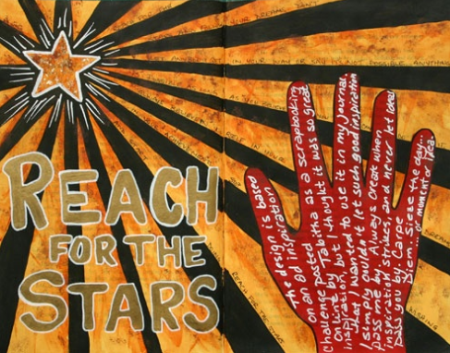
Assignment #1 Due: 10/ 7 / 16
- Cover Design*** - Create a design that encompasses the front and back cover. This design does NOT need to include your name unless you want it to.

- Name Design *** - Two page spread on the inside cover over to the first page of your visual journal. You MUST include a picture of yourself creatively...NO SELFIES! Your name MUST be included somehow.

- Mind Map - Are you right brained or left brained? Take an online test to find out and then share your results.
http://braintest.sommer-sommer.com/en/

Assignment #2 Due: 11 / 10 / 16

- What’s in the envelope?*** - Attach envelope to your journal pages. A background image should support the envelope and its contents. (TWO PAGES)

- Shattered Glass - Draw an object / image from observation but as if you were looking at it through a shattered window or mirror. (ONE PAGE)

- Class Choice Word *** - Creatively problem solve how to show this word. You DO need to include the text of the word somehow somewhere. (TWO PAGES)
Class Word: Seasons
Assignment #3 Due: 12 / 16 / 16

- Famous Artist Still Life - Research an artist and design a two-page spread that includes the following:
  - Artist’s Name
  - 3 Color images of the artist’s work
  - 5 facts
  - Art period / style of the artist
  - Background composition in the artist’s style
  - An added visual element of some sort in the artist’s style
***NO duplicate artists. Please “claim” your artist by letting Mrs. Impey know who you will be researching so that no one else can claim that artist.

- Magazine Spread*** - Rip a random piece of paper from a magazine. Attach it to one of your pages. Fill in the rest of your page.

- The Road Less Traveled (1 page)

Assignment #4 Due: 1 / 27 / 17

- Hands*** - Create an illustration that includes at least one hand. It can be traced or drawn realistically. You can include more than one hand.

2. Bubbles / Winter and/or Christmas

3. Haiku - Write a haiku (3 line poem, 5-7-5 syllables).
Illustrate your haiku. Include your haiku in your image.

Assignment #5 Due: 2 / 17 / 17

- “Be the change you wish to see in the world. It starts with you.” - Illustrate this quote and include it in your visual depiction.

- Things to remember…

- “Everything you can imagine is real.” ~Pablo Picasso*** - Include this quote in your visual depiction.

Assignment #6 Due: 3 / 31 / 17

- Class Choice ***

- Bucket List *** - Illustrate your bucket list.

- Choices - Create a visual depiction of the word choices. You may include the word in your depiction, but you do not need to.

Assignment #7 Due: 5 / 17 / 17

- How do you draw music? ***

- Favorite Art Medium *** - For this assignment ONLY, you may use one art medium if desired; mixed media will still be accepted.

- Inspirational Quote - Incorporate a quote you choose into your visual depiction.

Assignment #8 Due: 6 / 9 / 17

- “I found that I could say things with colors and shapes that I couldn’t say any other way -- things I had no words for.” ~Georgia O’Keeffe~

- “If you hear a voice within you saying, “You are not a painter,” then by all means paint...and that voice will be silenced.” ~Vincent Van Gogh~

- Reflection on school year.

