College Notes 1

Objective:

- What would you do with $2,100,000?
__________________________________________________________________________________________________________________________________________________________________________________________________________________________________________________________________________________________________________________________________________________________________________________________________________________________________________________________________

- How would that much money change your life and future?
__________________________________________________________________________________________________________________________________________________________________________________________________________________________________________________________________________________________________________________________________________________________________________________________________________________________________________________________________

- If you had an extra $400 to spend each week, what would you do with it?
______________________________________________________________________________________________________________________________________________________________________________________________________________________________________________________________________________
4. How much more money than a High School grad does a person with a Bachelor’s Degree make in their lifetime? ______________________________________________________________________
5. How much more money than a High School grad does a person with a Bachelor’s Degree make in a year?_____________________________________________________________________________
6. How much more money than a High School grad does a person with a Bachelor’s Degree make in a week? ____________________________________________________________________________
7. Who is more likely to have health insurance, a high school grad or a person with a Bachelor’s degree? What is the difference in percentages? Why is this important? _______________________________ _________________________________________________________________________________

8. Are you committed to going to college and finishing? This means earning your at least an Associate’s Degree, if not a Bachelor’s Degree. Why or why not?
__________________________________________________________________________________________________________________________________________________________________________________________________________________________________________________________________________________________________________________________________________________________________________________________________________________________________________________________________

HIGH SCHOOL | COLLEGE
Class every day from 8:15 – 3:30  (about 38 hours of class per week) | Class schedules vary, include breaks, could include days with no class  (about 15 – 18 hours of class per week)
Take 7 classes total | Take 3 – 5 classes total
Classes last all year (10 months) | Classes last one semester (4 months)
Homework every night for every class | One or two homework assignments each week for each class (but usually bigger homework assignments)
Required to take classes in all subjects | Choose classes that interest you
Teachers and parents guide and direct you (i.e. bothering you all the time) | You make your own decisions (which requires more maturity and responsibility)
All you get is a diploma. | You get a degree that gets you a good job and good money and a brighter future with many more opportunities.

Statistics on the Value of a College Education
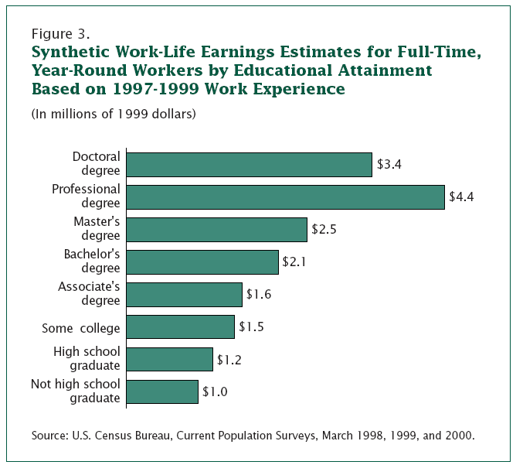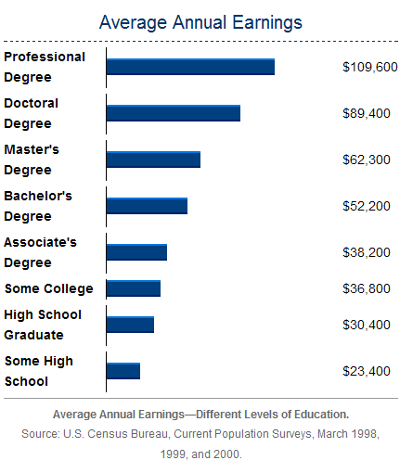
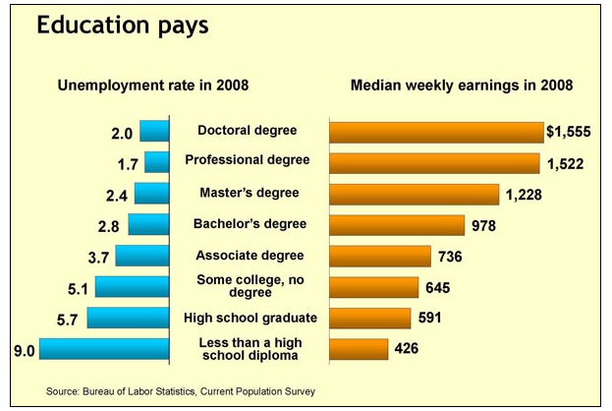
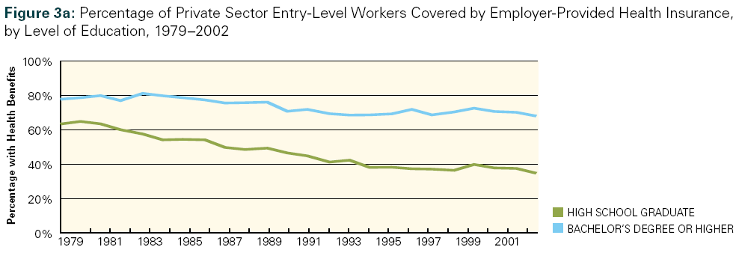
Views on a College Education
This assignment will take the place of the usual Free Response Question this week and count as a quiz grade. Please choose one of the quotes below. In a well-written, full-page essay:

- State the quote you chose and explain why you chose it.
- Explain why you think the quote was relevant to that person’s life.
- Explain why you think the quote is true or relevant in your life.
- Explain how the quote relates to your future college education and other life goals. Be as specific as possible.
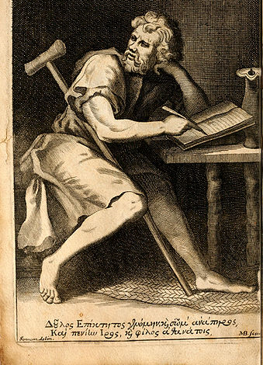
Quote 1: “Only the educated are free.” - Epictetus
Epictetus was a Greek philosopher who started his life as a slave in Rome. He was interested in philosophy, and with his master’s permission, he learned it from a tutor. Because of his education, he gained more respect and was eventually granted freedom and continued to study philosophy.

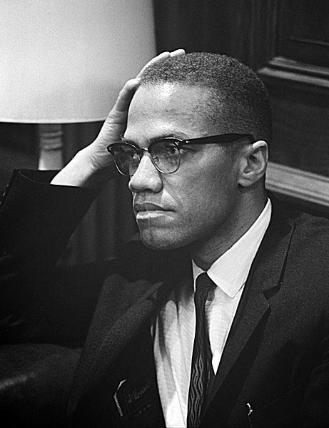
Quote 2: “Education is our passport to the future, for tomorrow belongs to the people who prepare for it today.” – Malcolm X

Malcolm X was an African-American Muslim minister, public speaker, and human rights activist in the 1950s – 1960s. He grew up in foster homes and when he was 21 he served eight years in prison for drug dealing and robbery. After his time in prison, he changed his life and began to passionately speak out for equal rights for African-Americans. Because of this work, Malcolm X has been called one of the greatest and most influential African-Americans in history.

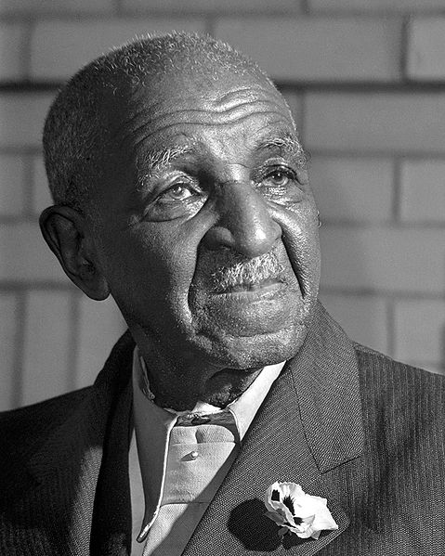
Quote 3: “Education is the key to unlock the golden door of freedom.” – George Washington Carver

George Washington Carver was born into slavery in Missouri in 1864. After slavery was abolished he was raised by his previous owners as their own child and they encouraged him to attend high school. Carver went on to college and earned a Bachelor’s and a Master’s degree. He led the Agriculture Department as a professor at Tuskegee University and made many important advancements in agriculture in his lifetime.

